Image Gallery Software

Use-Case-Realization Specification: Edit Image

Version <1.0>

Revision History

|  |  |  |  |
| --- | --- | --- | --- |
| **Date** | **Version** | **Description** | **Author** |
| 17/12/2020 | <1.0> | <details> | Do Minh Hieu |
|  |  |  |  |
|  |  |  |  |
|  |  |  |  |

Table of Contents

1. Introduction 2

1.1 Purpose 2

1.2 Scope 2

1.3 Definitions, Acronyms, and Abbreviations 2

1.4 References 2

1.5 Overview 2

2. Use-Case Specification 4

3. Interaction Diagrams 5

4. Class Diagrams 2

3. Derived Requirements 2

Use-Case-Realization Specification: Edit Image

# Introduction

## Purpose

This document describes how the Edit Image Use-Case is realized within the design model, in terms of collaborating objects.

## Scope

This document applies to the Image Gallery Software which will be developed Group 5C-18.

## Definitions, Acronyms, and Abbreviations

User – a person who use the software.

## References

None.

## Overview

In the following section, Use-Case Realization Specification of the Edit Image Use-Case of the Image Gallery Software is provided in detail. The first section is a textual description of the Use-Case specification. The following section contains diagrams (sequence and collaboration diagrams) describing how the use case is realized in terms of collaborating objects. The third section includes class diagrams with relationships that participate in the realization of the use case. The last section is an analysis of all requirements, such as non-functional requirements, on the use-case realization that are not considered in the design model, but that need to be taken care of during implementation.

# Use-Case Specification

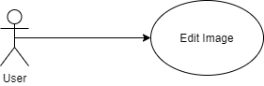

|  |  |
| --- | --- |
| **Name** | Edit Image |
| **Brief Description** | An user edits the picture’s information |
| **Actor** | User |
| **Flow of Events** | |
| **Basic Flow** | |
| 1. User open the image which they posted and click edit button. 2. A form of editing appears. 3. User change the content of their post as they want. 4. User click update button. 5. The information will be updated immediately. | |
| **Alterante Flows** | |
| **Title** | **Description** |
| Authentication fail | 1. User enter invalid or identical character. 2. System displays message to correct invalid information. |
| **Pre-Conditions** | |
| Not empty field. | |
| **Post-Conditions** | |
| **Title** | **Description** |
| Success | Success message is prompted and the information will be updated immediately. |
| Failure | Error message is prompted and user will stay in the editing section. |
| **Extension Points** | |
| None | |

# Interaction Diagrams

**Sequence Diagram:**

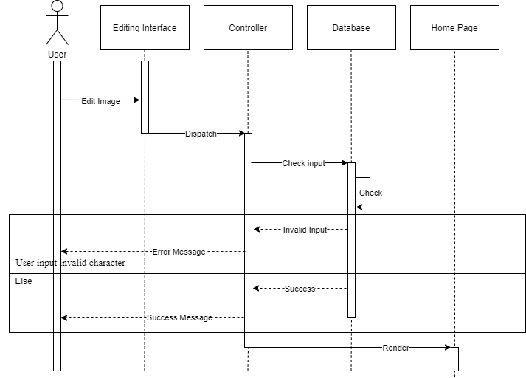

**Collaboration Diagram:** 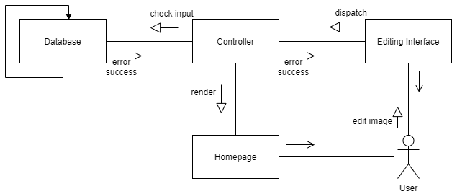

# Class Diagrams

# 

# Derived Requirements

None.